Region 2 Technical Rescue Team
Kitsap County Washington

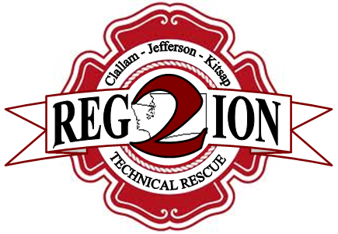

Strategic Plan 2018-2022

ACKNOWLEDGEMENTS
Region 2 Technical Rescue Team
Kitsap County- Lead Agency
Central Kitsap Fire & Rescue
5300 NW Newberry Hill Rd, Suite 101
Silverdale, WA 98383
(360) 447-3550

Technical Rescue Team Leadership
Jay Christian, CKFR- Team Coordinator
Jake Gillanders, PFD- Assistant Team Coordinator
Dave Schmidt, SKFR- Assistant Team Coordinator
Agency Leads
Bainbridge Island Fire dept- Zack Bussard
Bremerton Fire Dept- Tom Stanley
Central Kitsap Fire & Rescue- Dennis Elliott
Navy region NW F&ES- Jaren McCormick
North Kitsap Fire & Rescue-
Poulsbo Fire Dept- John Warnke

Administrative Board Kitsap DEM
Kitsap County Fire Chiefs Jason McMillan
Operations Board Kitsap 911
Kitsap County Operations Chiefs

Note- Formatting and content of this R2TRT Strategic Plan is derived from the CKFR Strategic Pan 2016-2020.

CONTENTS
A message from R2TRT Leadership

Section 1: Introduction
Our Mission, and Vision
Strategic Plan Development
Customer Priorities & Expectations

Section 2: Organizational Overview
History
Governance
Organizational Chart
Service Areas
R2TRT Resource List
Funding & Financial Report
Standards & Regulations

Section 3: Strategic Goals
State of the TRT
TRT Guiding Principles
12-month Goals
Long Term Goals

A Message from the Region 2 Technical Rescue Team Leadership:
On behalf of the men and women of the Region 2 Technical Rescue Team, I am honored to present the 2018-2022 Strategic Plan. The document was developed to create a shared vision for the numerous agencies involved in the Regional Technical Rescue Team as a unified organization. This Strategic Plan will serve as a guide by way of focused actions, for the rescue team as we strive to meet the challenges of the future.
Ten Areas of Strategic Focus continue to guide our future efforts:
- Provide Organizational Financial Stability
- Improve our Performance through Measurable Means
- Enhance Relationships with Neighboring Jurisdictions, Agencies and Businesses
- Anticipate and Plan for Change
- Improve Internal Communications
- Assemble and Retain a Highly Trained, Motivated, and Dedicated Workforce
- Manage Resources Responsibly
- Seek and Invest in Technology that Makes us more Effective and Efficient
- Actively Promote Community Relations, Outreach, Education and Involvement
- Promote and Expand Organizational Commitment to Safety
Over the course of the next five years, R2TRT members will endeavor to accomplish the Goals and Critical Tasks that support Areas of Strategic Focus. In the end, the organization will continue to pursue long-term improvement through the implementation of annual short-term goals, to become a stronger more agile organization, and reinforce our connection with the communities we serve.
Respectfully,
Jay Christian,
Kitsap TRT Coordinator

“When leaders constantly work to solve a crisis, it becomes difficult to plan for the future. This creates another crisis. The gathering of information and predicting future trends is crucial to an organization meeting changing demands.”
- Fire Chief Scott Weninger

SECTION 1- Introduction
Mission Statement
It is the mission of the Washington State Region 2 Technical Rescue Team to provide technical rescue capabilities for complex emergency operations, and during a major disaster provide an initial response until a FEMA USAR team begins operations.
Vision Statement
The R2TRT will serve as a regional technical rescue resource available to local fire agencies in Kitsap, Clallam, and Jefferson Counties and available for mobilization throughout the State of Washington for disaster response.
Strategic Plan Development
The first R2TRT Strategic Plan was developed in 2006, as a conceptual proposal for three counites, (Kitsap, Clallam, and Jefferson) and all participating fire agencies. The original plan described the team mission, vision and history. It also included aspirations for future requirements that would outline agency participation, training, funding, equipment caches and operating guidelines.
However, as a decade passed, the commitment of the three-county rescue team waivered, as federal funds dwindled so did collaborative participation. These conceptual goals were left unfinished and never fully developed, and the plan failed. Remarkably, the teams remained independently supported in all three counties and continued to train and support technical rescue operations.
In 2017, the need for reconstructing a collaborative partnership between agencies and future planning was realized. A commitment was renewed for the revitalization of the three-county rescue team.
The purpose of this new strategic plan is to re-organize, prioritize and execute a clear path towards safer, more effective and efficient technical rescue operations for all three counties. The scope of this plan is drafted for the Kitsap County agencies primarily, then evolve and advance the plan as a guide for a common vision for Kitsap, Clallam and Jefferson incorporated into the 2022-2026 Strategic Plan.
Customer Expectations
It is recognized that a tiered response to rescue incidents will be used to provide a prompt initial response, reinforced to the level necessary using the closest available resources. Local fire agencies are encouraged to develop the appropriate initial response to all natural and manmade rescue incidents. The R2TRT will be trained and equipped to provide timely technical search and rescue services to local fire agencies and their communities.
SECTION 2 - Organizational Overview
History
Geologists, emergency managers, and fire service leaders have long recognized the potential for catastrophic earthquakes in the Puget Sound and the potential for significant structural collapse. Such an event could place extreme demand on the fire service for confined space and structural collapse rescue services. Rapid growth in the Puget Sound Region has increased the frequency of emergencies in confined spaces and open trenches. This demand could quickly exceed and overwhelm the available capacity of emergency services.
Adding to the need for Urban Search and Rescue (USAR) capability is the potential for terrorist attacks. Terrorists have demonstrated their capacity for destroying large buildings as a vehicle to incite terror. The events in Oklahoma City and attacks on the World Trade Center and Pentagon drove that message home.
The Federal government, recognizing the need for USAR services, long ago established 28 federal USAR teams to respond to Presidentially declared disasters where tasks exceeded local capability. The reality is that one or more of these teams responding to a Western Puget Sound disaster would not be on-site and operational for at least 24 to 36 hours. During this crucial time the responsibility for providing USAR services would fall to local fire service responders.
Consequently, it became obvious that Washington State Region 2 Homeland Security Council (R2HSC) needed an intermediate US&R response capability, a capability between what local fire service agencies can provide immediately and the large-scale services that a federal US&R team could eventually bring to bear. In 2003, R2HSC surveyed the Regional fire services to assess what level of commitment and capability fire agencies were willing to commit to. At that time, only Bainbridge Island Fire Department and Clallam County Fire District No.3 committed to providing Technician Level Rescue response within the Region 2 boundaries.
Recognizing the need for an intermediate response, the R2HSC committed to supporting development of technical rescue capability that would be available across the region. Clallam County Fire District No.3 (CCFD#3) and Bainbridge Island Fire Department (BIFD), who already had functional technical rescue teams, agreed to work with the R2HSC to develop a regional response capability. In early 2006, Port Angeles Fire Department (PAFD) joined the CCFD#3 team to create a Clallam County Technical Rescue Team (CCTRT).
The concept established two strategically located equipment caches, one stored on the East side of the Hood Canal at BIFD, and one stored on the West side of the Hood Canal at CCFD#3 for quick transporting to the scene of a US&R disaster. Fire departments participating in the R2TRT have trained technical rescue and US&R technicians on staff and have agreed to dispatch to the scene to assist the local fire service agency in need of that expertise.
Benefits of a Regional USAR Team
- Expedites the availability of specialized emergency response resources within the first 24 hours, resulting in fewer fatalities and less severe injuries.
- Reduces extended response time due to loss of locally impacted emergency response resources.
- Produces more efficient and expedited delivery of emergency response resources.
Service Delivery
The capabilities of R2TRT include:
- Primary disciplines in Rope Rescue, Structural Collapse, Confined Space, and Trench Collapse.
- Secondary disciplines provide Machinery/Vehicle, Swiftwater/Flood Search and Rescue throughout the region where no capability currently exists.
- In 2017, the R2TRT responded to 14 technical rescue call outs. There was no tracking mechanism for the number of rescue responses prior to 2017.
Funding
Funding for the R2TRT has been challenging due to constantly decreasing amounts of federal grant money. At some point, all costs are will be borne by participating agencies, as it had before the R2HSC support existed. Participating agencies need to anticipate a loss of outside funding and include anticipated costs in their own budget planning process.
Each participating agency will be responsible for their agency's personnel and equipment costs. R2HSC will provide equipment and training, as funding allows. The participating agencies will seek authorized reimbursement under the Washington State Mobilization Plan when possible.
Cache Management & Transport
Vehicles and equipment that an agency purchased or that Region 2 Homeland Security provided to an agency as part of the R2TRT Equipment Cache, are the property solely of that agency. The agency agrees to respond the equipment as part of the equipment cache to an emergency within the Region according to the operational plan, maintain the equipment and vehicles, and continue to train personnel in its use.

Governance- Authority to Respond & Team Activation
According to the 2006 Conceptual Plan, the authority for the R2TRT to respond is delegated to the team by the Inter-Local Agreement (ILA) approved and signed by the emergency management and response agencies of Clallam, Jefferson and Kitsap Counties. However, the plan conceded that this document was not completed and was a work in progress. Therefore, no signed document Inter-Local Agreement currently exists between the three counties that is known.
The original plan also stated the R2TRT may respond as part of a state mobilization effort at the request of Washington State Emergency Management.
Participation will be made up of three county teams:
The Kitsap County team consisting of members from the following agencies: Bremerton Fire Department, North Kitsap Fire & Rescue, Central Kitsap Fire & Rescue, South Kitsap Fire & Rescue, Bainbridge Island Fire Department, Poulsbo Fire Department, and Navy Region Northwest Fire & Emergency Services.
The Clallam County Team consisting of members from the following agencies: Clallam County Fire District No. 3, Clallam County Fire District 2, and Port Angeles Fire Department.
The Jefferson County Team consists of members from the following agencies: Port Ludlow Fire & Rescue, East Jefferson Fire & Rescue, and NRNWFES Indian Island.
Additional participation may include other Fire Departments and Public safety agencies of Clallam, Jefferson, and Kitsap Counties. The membership of the R2TRT will be open to any qualified personnel of these agencies. Agency personnel remain employees or volunteers of their host agency.
In 2010, the 7 fire agencies of the Kitsap County Team did sign an ILA giving authority to the technical rescue team to respond, with BIFD being the Lead Agency. In 2017, the Kitsap County ILA was renewed with Lead Agency status transferred to Central Kitsap Fire and Rescue. This agreement binds the 7 agencies in:
- Authority, purpose & scope
- Operational guidance and duties
- Lead agency and member agency status
- State mobilization
No similar ILA currently exists in Clallam or Jefferson Counties.

ORGANIZATION

Conceptually there are two organizational charts. One for the Region Team, and one for the County Teams.

Kitsap County TRT
Policy Board

Operations Board
Special Operations – CKFR
Rick O’Rourke
Team Coordinator
Jay Christian
Assistant Team Coordinator
Training Officer
Dave Schmidt
Assistant Team Coordinator
Administrative Officer
Jake Gillanders

Department Leads | Disciplines with Limited Capabilities
BFD – Tom Stanley  BIFD – Zach Bussard  CKFR – Dennis Elliot  NKFR – Open  NRNW – Jeran McCormick  PFD – John Warnke  SKFR – Dave Schmidt | - Tower Rescue  - Mine / Cave Rescue  - Animal Rescue  - Water / Ice Rescue  - Vehicle / Machinery Rescue  - Wilderness Rescue  - Hazardous Materials
Policy Board
Consists of representative of a Fire Chief or designee from each member agency
Equipment
Zach Bussard
Medical
Carol Mezen
Discipline Leads

Rope
Gillanders
Bittlingmaier
Bussard
Baze
Collapse
McCormick
Elliott
Rye

Trench
Stanley
Warnke
Schmidt
Confined Space
Elliott
Wicus
Zielinski

Haz-Mat
NRNW

Service Areas

The Region 2 Technical Rescue service areas include the Washington Region 2 Homeland Security of Clallam, Jefferson, and Kitsap Counties.

Area demographics:
Clallam County population: 71,404 Square miles: 2,671
R2TRT Participating Fire Agencies: Clallam FD 2, Clallam FD 3, Port Angeles FD

Jefferson County population: 29,872 Square Miles: 2,183
R2TRT Participating Fire Agencies: Port Ludlow FR, East Jefferson FR, NRNWFS

Kitsap County Population: 251,133 Square Miles: 566
R2TRT Participating Fire Agencies: North Kitsap FR, Bainbridge Island FD, Poulsbo FD, Central Kitsap FR, South Kitsap FR, NRNWES,

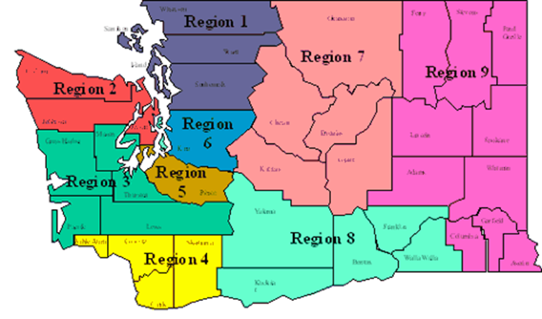

Kitsap County Rescue Resources
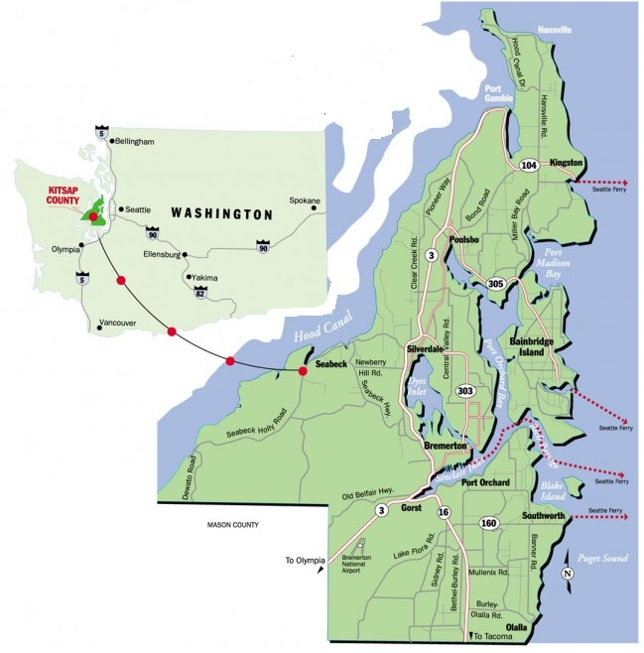

- Rescue 21 – Bainbridge Island Fire Department
- Rescue 61 – NRNW
- Ladder 51- CKFR
- Boat 51- Sea Legs 7.0 - Surface Water Rescue CKFR
- Ice Rescue- CKFR
- ATV- CKFR off-road vehicle
- Tech Rescue Trailer 51- Misc.
- HAZ MAT- NRNW & CKFR Decontamination Trailer

Rescue 21 – Bainbridge Island Fire Department
Make & Model | Hackney
Address | Yes
Cruise Speed | 65 mph
Seats | 2
Radio | Yes
Order Response Time | 30 Minutes
Rope Rescue: | Yes
Confined Space Rescue: | Yes
Structural Collapse: | Yes
Trench Rescue: | Yes
Water Rescue: | No
- Rescue 61 – NRNWFES
Make & Model | 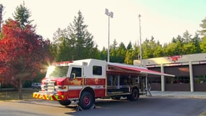
Address | Yes
Cruise Speed | 65 mph
Seats | 4
Radio | Yes
Order Response Time | 30 Minutes
Rope Rescue: | Yes
Confined Space Rescue: | Yes
Structural Collapse: | Yes
Trench Rescue: | Yes
Water Rescue: | No
 | Command cab with WIFI and computers/printers

Ladder 51 – CKFR
Make & Model | 1997 Pierce 105’  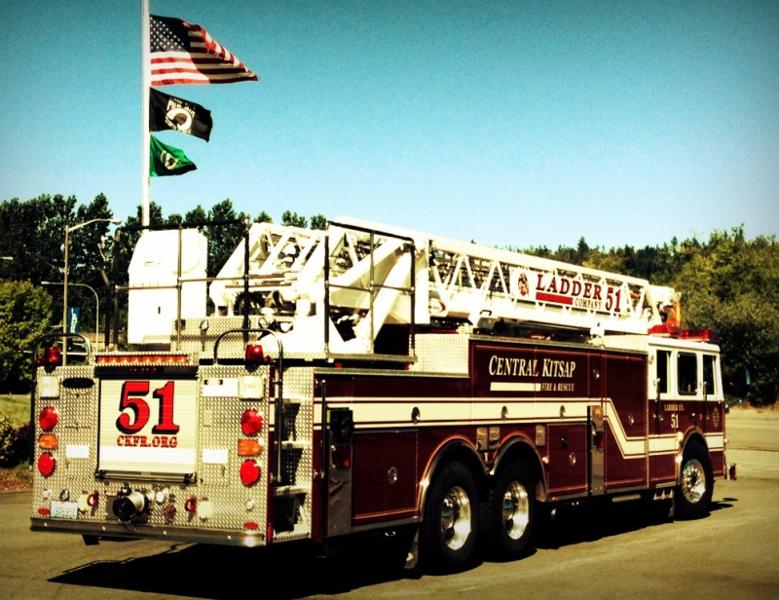  Ladder Truck
Address | Yes
Cruise Speed | 65 mph
Seats | 4
Radio | Yes
Order Response Time | 30 Minutes
Rope Rescue: | Yes
Confined Space Rescue: | Yes
Structural Collapse: | Yes
Trench Rescue: | Yes
Water Rescue: | No

- B51 Water Rescue – CKFR
Make & Model | CKFR Boat 51  Sea Legs Amphibious Boat
Address | Yes
Cruise Speed | 45 mph
Seats | 4
Radio | Yes
Order Response Time | 30 Minutes  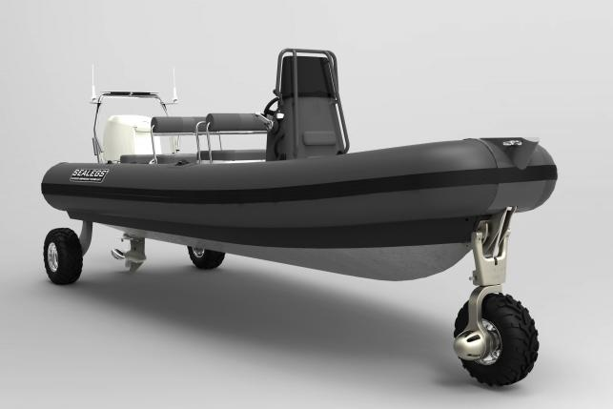
 | Amphibious Surface Water Rescue Boat. No launch site required.

- Ice Rescue/ Lake Water Rescue – CKFR
Make & Model | Oceanid RDC Water Rescue Craft
Address | Yes
Cruise Speed | 5 mph
Seats | 4
Radio | Yes
Order Response Time | 30 Minutes
Water Rescue: | Yes- Can deploy quickly with SCBA bottle. Water rescue technicians for ice and surface water.

- ATV Wilderness Rescue – CKFR
Make & Model | John Deere  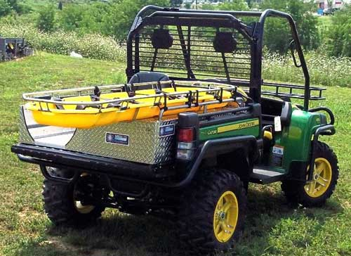
Address | Yes
Cruise Speed | 30 mph
Seats | 4
Radio | Yes
Order Response Time | 30 Minutes
 | CKFR ATV with patient skid
Type: | None

- Technical Rescue Trailer – CKFR
Make & Model | Technical Rescue Trailer  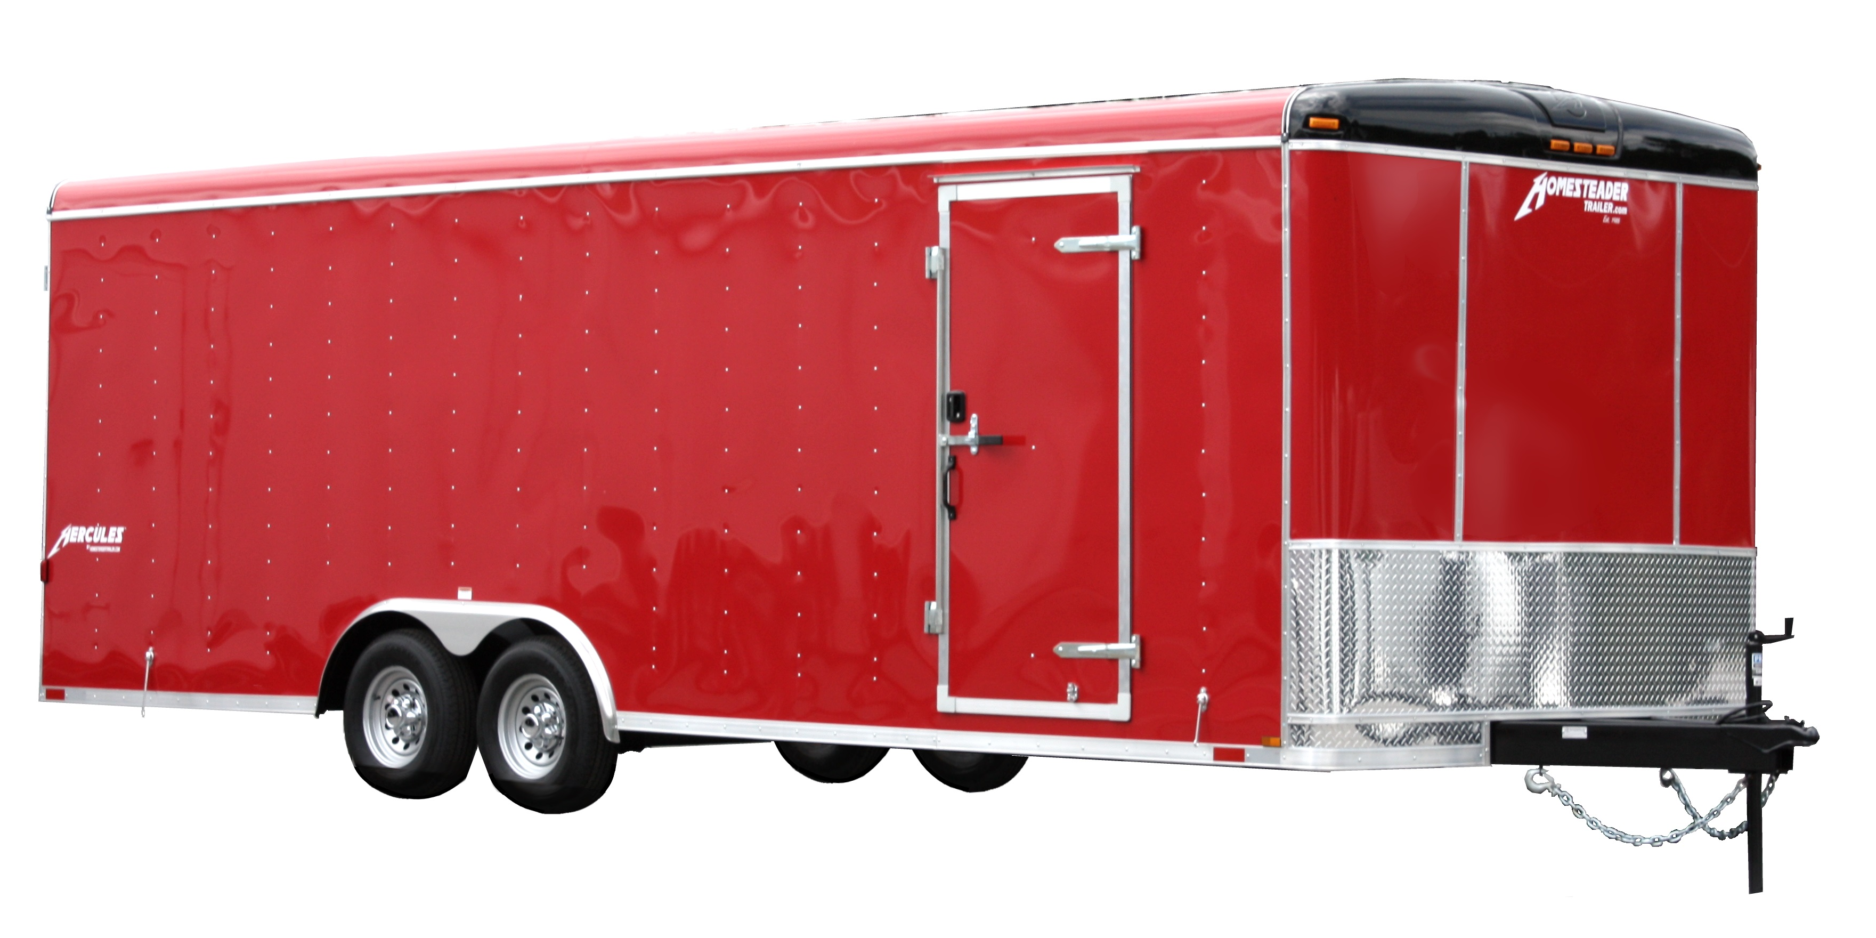
Address | Yes
Cruise Speed | 30 mph
Seats | 4
Radio | Yes
Order Response Time | 30 Minutes
Rope Rescue: | YES
Confined Space Rescue: | YES
Structural Collapse: | YES
Trench Rescue: | YES
Water Rescue: | No
 | CKFR station 51. Reserve trailer for extended call outs/response. Also stores trailing materials.
- HAZ MAT- NRNWFES & CKFR DECON TRAILER
Make & Model | HAZ MAT 61 & Decon Trailer
Address | Yes
Cruise Speed | 30 mph
Seats | 4
Radio | Yes
Order Response Time | 30 Minutes
Rope Rescue: | No
Confined Space Rescue: | No
Structural Collapse: | No
Trench Rescue: | No 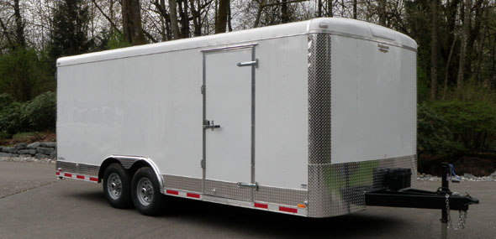
Water Rescue: | No
Notes: | NRNWFES Haz Mat Response Unit.  CKFR also a DEM Decon Trailer
Ordering Procedure:

Clallam County Rescue Resources
- Rescue 33 – Technical Rescue
- Rescue 34 – Primary Rescue
- Marine 34 – Swiftwater & Marine Rescue
- UTV – TOC
- MCB- Mass casualty bus
- Haz-Mat – Connex

Rescue 33- Clallam County Fire District #3 (Located at CCFD#3 Training & Operations Center)
ake & Model | Ford F550/Wells Cargo  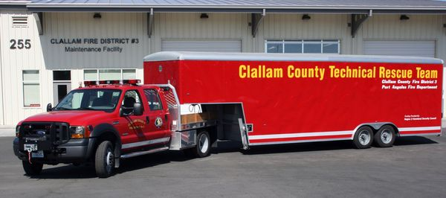
Address | Carlsborg Rd, Sequim
Cruise Speed | 65 mph
Seats | 6
Radio | Yes
Order Response Time | 30 Minutes
Rope Rescue: | Yes
Confined Space Rescue: | Yes
Structural Collapse: | Yes
Trench Rescue: | Yes
Water Rescue: | No
Notes: | Rescue Rope, Tripod, Pneumatic Trench Shores, High Pressure lifting bags,  Concrete chain-saw, Breakers, Confined space air & comms, Delsar seismic/acoustic device, Search camera, Jaws of Life., Construction tools.  Petrogen cutting torch, Exothermic Torch.

- Rescue 34 – Clallam County Fire District #3
Make & Model | Freightliner, Superior  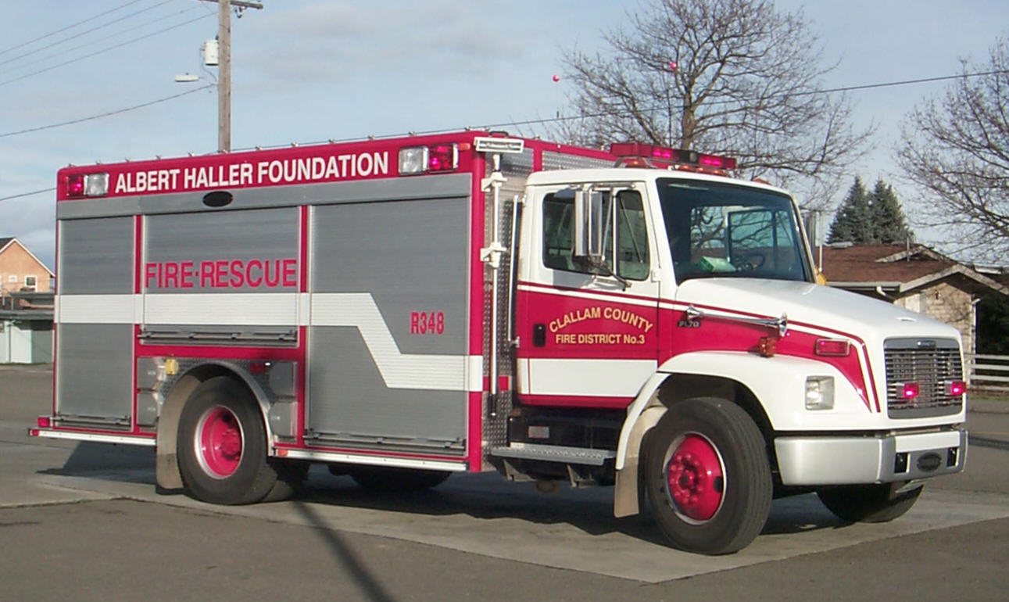
Address | 323 N. 5th Ave, Sequim WA
Cruise Speed | 65 mph
Seats | 2
Radio | Yes
Order Response Time | 5 Minutes
Rope Rescue: | Yes
Confined Space Rescue: | Yes
Structural Collapse: | Yes
Trench Rescue: | Yes
Water Rescue: | No
Notes: | Vehicle extrication; Jaws of Life., High Pressure lifting bags, Chain saw, Rescue Rope, Stabilization Struts, Breathing Air Systems, Scene lighting,  Assorted tools, ALS equipped.

Marine 34 – Clallam County Fire District #3
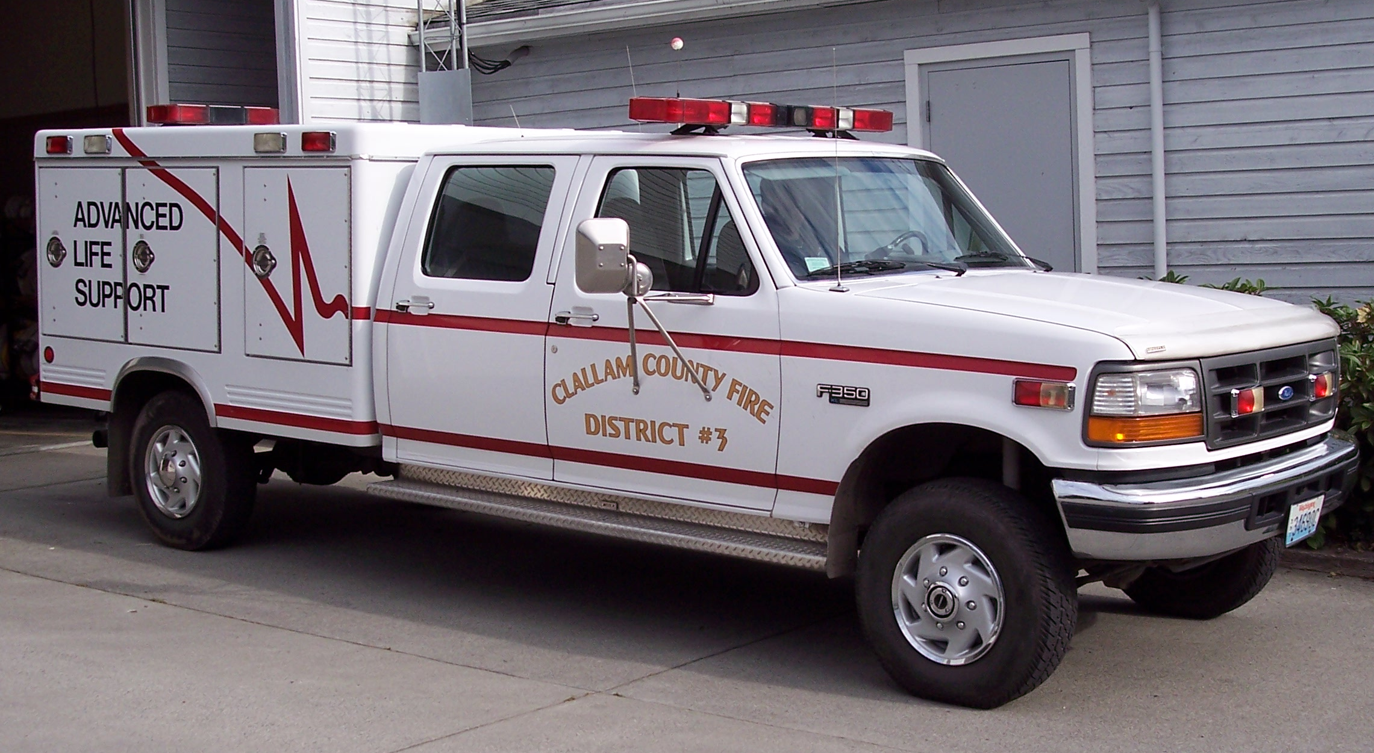
Make & Model | Ford F-350
Address | 323 N. 5th Ave, Sequim WA
Cruise Speed | 65 mph
Seats | 5
Radio | Yes
Order Response Time | 10 Minutes
Water Rescue: | Yes
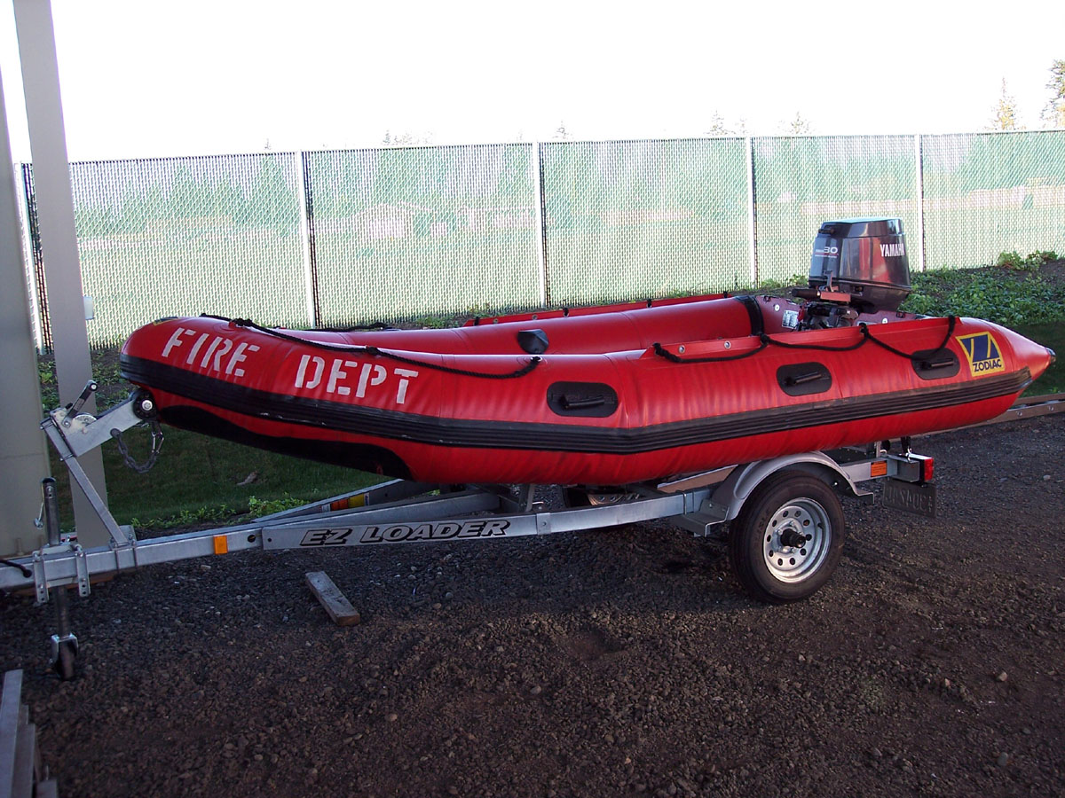 | Notes:  Swiftwater Rescue, PFD’s, Pneumatic line crossing gun, Throwbags, PPE-Drysuits, Inflatable Kayaks, 4-Person River Raft, Fire hose inflator, Mud Rescue device. Marine Rescue, RIB with Johnson Outboard.

- UTV – Clallam County Fire District #3
(Located at CCFD#3 Training and Operations Center)
Make & Model | Polaris Ranger  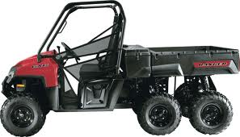
Address | Carlsborg Rd, Sequim WA
Cruise Speed | 45 mph
Seats | 3
Radio | No
Order Response Time | 15 Minutes
Notes: | Utility vehicle for off road patient transport. Has a wildland module with water tank and pump. Trailer has split apart patient litter and a litter wheel for patient extrication. Helmets.

MAB- Clallam County Fire District #3

(Located at CCFD#3 Training & Operations Center)
Make & Model | Bus  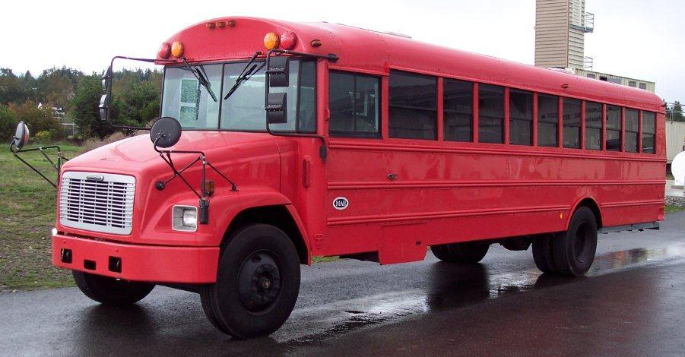
Address | Carlsborg Rd, Sequim
Cruise Speed | 45 mph
Seats | 6+
Radio | Yes
Order Response Time | 30 Minutes
Rope Rescue: | No
Confined Space Rescue: | No
Structural Collapse: | No
Trench Rescue: | No
Water Rescue: | No
 | Mobile Ambulance Bus. Can transport ambulatory and non-ambulatory patients.

Hazardous Materials Decon- Clallam County Fire District #3
(Located at CCFD#3 Training & Operations Center)
Make & Model | 20’ Connex Shipping Container  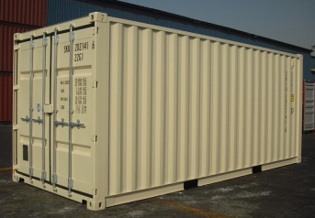
Address | Carlsborg Rd, Sequim
Cruise Speed | 45 mph
Seats | 0
Radio | No
Order Response Time | 30 Minutes
Rope Rescue: | No
Confined Space Rescue: | No
Structural Collapse: | No
Trench Rescue: | No
Water Rescue: | No
 | Decontamination suite with Hot water heater, Air heater, Responder Rehab Cart, Powered Air Purifying Respirators, Level C suits, Detergents, SKED Skyhook patient retrieval system, Traffic control, Misc. Brushes. Disposable clothing (Tyvek).

Jefferson County Rescue Resources
- Air 11 – East Jefferson Fire Rescue
- Marine 14 – East Jefferson Fire Rescue
- Trench Rescue Trailer – East Jefferson Fire Rescue
- Santi Can – East Jefferson Fire Rescue

Air 11 – East Jefferson Fire & Rescue
Make & Model | Freightliner FL60  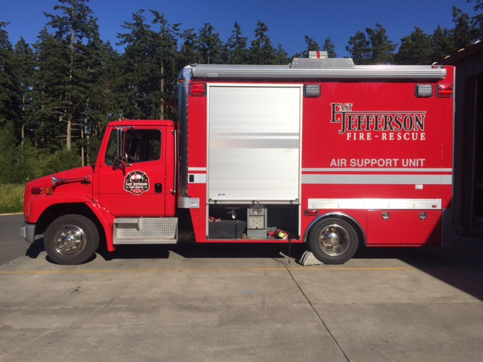
Address | 33 Critter Ln, Port Townsend
Cruise Speed | 65 mph
Seats | 2
Radio | Yes
Order Response Time | 5 Minutes
Rope Rescue: | No
Confined Space Rescue: | No
Structural Collapse: | No
Trench Rescue: | No
Water Rescue: | No
Light Support with tower, Breathing Air System, Chainsaw, Rehab supplies, BLS, Wash Station.
Primary Air/Light and Rehab
Type:

- Marine 14 – East Jefferson Fire & Rescue
Make & Model | 2001 22’ Lee Shore Fire Boat w/trailer  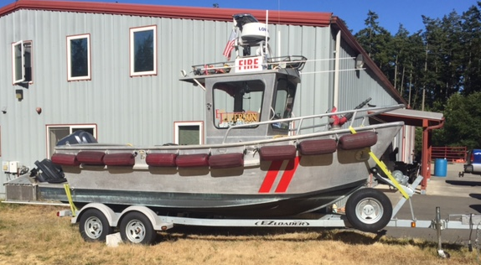
Address | 33 Critter Ln, Port Townsend
Cruise Speed | 65 mph trailered/ 26 knots water
Seats
Radio | Yes
Order Response Time | 60 Minutes
Rope Rescue: | No
Confined Space Rescue: | No
Structural Collapse: | No
Trench Rescue: | No
Water Rescue: | Yes
 | - Yamaha outboard, Has 18 HP Fire Pump on board.

- Trench Rescue Trailer – East Jefferson Fire & Rescue
Make & Model
Address | 33 Critter Ln, Port Townsend
Cruise Speed
Seats
Radio | Yes
Order Response Time | 60 Minutes
Rope Rescue: | No
Confined Space Rescue: | No
Structural Collapse: | No
Trench Rescue: | No
Water Rescue:

Santi Can with Wash station- East Jefferson Fire & Rescue
Make & Model | Santi Can on Trailer
Address | 33 Critter Ln, Port Townsend
Cruise Speed | 45 mph
Seats | 1
Radio | NO
Order Response Time | 60 Minutes
Notes:

Funding
In the beginning R2TRT funding was provided by the R2HSC to purchase equipment and provide members training. It is unclear at this time exactly how much money was spent or what exactly it was spent on. This needs to be further investigated for full transparency.
Financial Report
Because the Kitsap County Team participates in an ILA, there are financial contributions made by each agency for sustainability. The full report follows:
Summary:

REVENUE: |  |  |  | Total Revenue: $ 110,000.00  Total Expenses: $ 43,721.98  ACCOUNT BALANCE: $ 66,278.02
9/1/2010 | BIFD |  |  |  |  | $ 2,500.00
9/20/2010 | NKF&R |  |  |  |  | $ 2,500.00
9/24/2010 | BFD |  |  |  |  | $ 2,500.00
9/29/2010 | SKF&R |  |  |  |  | $ 2,500.00
9/30/2010 | CKF&R |  |  |  |  | $ 2,500.00
9/30/2010 | PFD |  |  |  |  | $ 2,500.00
 |  |  |  |  |  |  |  |  | TOTAL 2010 REVENUE: |  |  |  |  |  |  |  | $ 15,000.00
9/1/2011 | BIFD |  |  |  |  | $ 2,500.00
10/3/2011 | BFD |  |  |  |  | $ 2,500.00
10/7/2011 | SKF&R |  |  |  |  | $ 2,500.00
10/13/2011 | CKF&R |  |  |  |  | $ 2,500.00
10/20/2011 | NKF&R |  |  |  |  | $ 2,500.00
10/21/2011 | PFD |  |  |  |  | $ 2,500.00
 |  |  |  |  |  |  |  |  | TOTAL 2011 REVENUE: |  |  |  |  |  |  |  | $ 15,000.00
9/1/2012 | BIFD |  |  |  |  | $ 2,500.00
9/12/2012 | KC DEM - Trailer contribution |  |  |  |  | $ 5,000.00
9/18/2012 | NKF&R |  |  |  |  | $ 2,500.00
9/24/2012 | BFD |  |  |  |  | $ 2,500.00
9/27/2012 | CKF&R |  |  |  |  | $ 2,500.00
9/27/2012 | SKF&R |  |  |  |  | $ 2,500.00
10/19/2012 | PFD |  |  |  |  | $ 2,500.00
 |  |  |  |  |  |  |  |  | TOTAL 2012 REVENUE: |  |  |  |  |  |  |  | $ 20,000.00
9/1/2013 | BIFD |  |  |  |  | $ 2,500.00
9/26/2013 | CKF&R |  |  |  |  | $ 2,500.00
10/1/2013 | BFD |  |  |  |  | $ 2,500.00
10/1/2013 |  |  |  | NKF&R |  |  |  |  | $ 2,500.00
10/2/2013 |  |  |  | SKF&R |  |  |  |  | $ 2,500.00
10/17/2013 |  |  |  | PFD |  |  |  |  | $ 2,500.00
 |  |  |  |  |  |  |  |  | TOTAL 2013 REVENUE: |  |  |  |  |  |  |  | $ 15,000.00
9/1/2014 |  |  |  | BIFD |  |  |  |  | $ 2,500.00
9/22/2014 |  |  |  | CKF&R |  |  |  |  | $ 2,500.00
9/29/2014 |  |  |  | BFD |  |  |  |  | $ 2,500.00
9/29/2014 |  |  |  | NKF&R |  |  |  |  | $ 2,500.00
9/29/2014 |  |  |  | SKF&R |  |  |  |  | $ 2,500.00
12/18/2014 |  |  |  | PFD |  |  |  |  | $ 2,500.00
 |  |  |  |  |  |  |  |  | TOTAL 2014 REVENUE: |  |  |  |  |  |  |  | $ 15,000.00
10/1/2015 |  |  |  | BIFD |  |  |  |  | $ 2,500.00
10/2/2015 |  |  |  | CKF&R |  |  |  |  | $ 2,500.00
10/5/2015 |  |  |  | BFD |  |  |  |  | $ 2,500.00
10/2/2015 |  |  |  | NKF&R |  |  |  |  | $ 2,500.00
10/8/2015 |  |  |  | SKF&R |  |  |  |  | $ 2,500.00
11/6/2015 |  |  |  | PFD |  |  |  |  | $ 2,500.00
 |  |  |  |  |  |  |  |  | TOTAL 2015 REVENUE: |  |  |  |  |  |  |  | $ 15,000.00
10/1/2016 |  |  |  | BIFD |  |  |  |  | $ 2,500.00
10/31/2016 |  |  |  | CKF&R |  |  |  |  | $ 2,500.00
10/24/2016 |  |  |  | BFD |  |  |  |  | $ 2,500.00
10/31/2016 |  |  |  | NKF&R |  |  |  |  | $ 2,500.00
10/31/2016 |  |  |  | SKF&R |  |  |  |  | $ 2,500.00
11/7/2016 |  |  |  | PFD |  |  |  |  | $ 2,500.00
 |  |  |  |  |  |  |  |  | TOTAL 2016 REVENUE: |  |  |  |  |  |  |  | $ 15,000.00
 |  |  |  |  |  |  |  |  | TOTAL REVENUE: |  |  |  |  |  |  |  | $ 110,000.00
EXPENSES: |  |  | History from 2011 to present
3/9/2011 |  |  | BI Ace - Restriping spray |  |  |  |  | $ 43.35
3/9/2011 |  |  | BI Ace - Spray paint |  |  |  |  | $ 32.55
6/15/2011 |  |  | Tacoma Screw - paint |  |  |  |  | $ 5.27
6/17/2011 |  |  | Fred Hill - Eco blocks |  |  |  |  | $ 320.37
6/17/2011 |  |  | Excavator rental - trench drill |  |  |  |  | $ 508.79
 |  |  |  |  |  |  |  | TOTAL EXPENSES 2011: |  |  |  |  |  |  |  | $ 910.33
3/15/2012 |  |  | Central Market - Drill supplies |  |  |  |  | $ 21.00
5/17/2012 | Kitsap Lumber-Magnetic sweeper |  |  |  | $ 30.28
6/1/2012 | REI - Compass, Garmin topo map |  |  |  | $ 273.39
6/4/2012 | Freeway Trailer - 20' Express Wagon |  |  |  | $ 20,801.90
6/4/2012 | Safeway - drill supplies |  |  |  | $ 53.86
6/5/2012 | Safeway - drill supplies |  |  |  | $ 20.93
6/12/2012 | DOL - trailer registration |  |  |  | $ 29.75
8/1/2012 | WSDOT: trailer bridge toll |  |  |  | $ 10.00
8/2/2012 | Armor Coatings - trailer |  |  |  | $ 1,307.30
8/20/2012 | CIAW - trailer insurance |  |  |  | $ 186.00
9/4/2013 | Bridge Toll - Tacoma Narrows Bridge |  |  |  | $ 6.00
9/5/2012 | Freeway Trailer - awning door roller |  |  |  | $ 20.65
9/5/2012 | Jennings Equipment - honda generator |  |  |  | $ 4,145.17
9/5/2012 | Signwarehouse |  |  |  | $ 358.84
10/5/2013 | Star Rental: Excavator Trench Drill |  |  |  | $ 400.89
12/13/2012 | Safeway - Rope evaluation supplies |  |  |  | $ 12.66
12/26/2012 | Costco - Rope Evaluation supplies |  |  |  | $ 86.60
 |  |  |  |  |  |  |  | TOTAL EXPENSES 2012: |  |  |  |  |  |  |  | $ 27,765.22
1/31/2013 | Detroit Ind. Tool - reciprocating saw |  |  |  | $ 395.48
6/10/2013 | Battery zone - batteries |  |  |  | $ 1,091.40
6/14/2013 | West Hills 76 - fuel |  |  |  | $ 42.44
6/19/2013 | Kitsap Lumber - fasteners |  |  |  | $ 134.18
6/20/2013 | West Hills 76 - fuel |  |  |  | $ 18.05
9/20/2013 | Advanced Rentals - excavator |  |  |  | $ 413.16
 |  |  |  |  |  |  |  | TOTAL EXPENSES 2013: |  |  |  |  |  |  |  | $ 2,094.71
4/6/2014 | WSF: Dilley OSO |  |  |  | $ 13.55
4/7/2014 | Darrington Motor Inn: Dilley OSO |  |  |  | $ 105.51
4/7/2014 | WSF: Dilley OSO |  |  |  | $ 21.40
6/18/2014 | Apple: Enforcer App |  |  |  | $ 32.60
6/1/2014 | Yank-A-Part: Extrication vehicles |  |  |  | $ 150.00
6/19/2014 | Rescue Response: Enforcer CMC |  |  |  | $ 862.26
6/23/2014 | Star Rentals: Excavator |  |  |  | $ 375.02
9/23/2014 | Star Rentals: Excavator |  |  |  | $ 418.50
12/15/2014 | Linx: Patches |  |  |  | $ 233.00
 |  |  |  |  |  |  |  | TOTAL EXPENSES 2014: |  |  |  |  |  |  |  | $ 2,211.84
2/9/2015 | Good2Go: Bridge toll |  |  |  | $ 6.50
3/16/2015 | Lowes: 27 Gallon Tote |  |  |  | $ 78.13
8/21/2015 | Amazon: Hi-Lift jack |  |  |  | $ 101.39
8/21/2015 | Amazon: Pelican Case |  |  |  | $ 117.75
9/3/2015 | Mariners: Tech Rescue Exercise |  |  |  | $ 493.20
9/30/2015 | Ferry Transports |  |  |  | $ 50.60
 |  |  |  |  |  |  |  | TOTAL EXPENSES 2015: |  |  |  |  |  |  |  | $ 847.57
1/14/2016 | Rescue Direct: Reference manuals |  |  |  | $ 286.91
1/29/2016 | Waste Management: waste disposal |  |  |  | $ 343.77
2/6/2016 | Lowes: TR-51 class supplies |  |  |  | $ 107.58
2/7/2016 | Lowes: TR-1 heater |  |  |  | $ 459.58
2/8/2016 | Home Depot: TR-1 fuel cans |  |  |  | $ 86.70
2/11/2016 | Star Rentals: Excavator |  |  |  | $ 450.18
2/12/2016 | Lowes: Maintenance supplies |  |  |  | $ 151.46
2/22/2016 | Lowes: TR 51 cabinets |  |  |  | $ 998.89
5/1/2016 | Waste Management: waste disposal |  |  |  | $ 802.79
6/17/2016 | Active911: KC tech rescue annual subscr. |  |  |  | $ 223.25
8/31/2016 | AHS Rescue: ropes |  |  |  | $ 968.36
9/14/2016 | Pigeon Mt: ropes |  |  |  | $ 236.42
11/16/2016 | Rescue Direct: Reference manuals |  |  |  | $ 1,277.71
 |  |  |  |  |  |  |  | TOTAL EXPENSES 2016: |  |  |  |  |  |  |  | $ 6,393.60
6/7/2017 | Arrow Lumber: lumber |  |  |  | $ 696.08
8/28/2017 | Sea Western: fill station adapter |  |  |  | $ 2,302.63
9/14/2017 | Nathan Cleaver: Septic design |  |  |  | $ 500.00
 |  |  |  |  |  |  |  | TOTAL EXPENSES 2017: |  |  |  |  |  |  |  | $ 3,498.71
 |  |  |  |  |  |  |  | TOTAL EXPENSES: |  |  |  |  |  |  |  | $ 43,721.98

Standards & Regulations
This is an overview of the standards and regulations pertaining to technical rescue operations, personnel, and equipment. The significant NFPA standards are 1670, 1006, and 1983 in addition to the Washington Administrative Code, Chapter 296-305 Safety Standards for firefighters. Briefly describing these standards may help eliminate confusion.

National Fire Protection Association (NFPA) is committed to advocating consensus codes and standards for fire and safety issues. These standards prompt a high level of safety to which all fire service personnel and organizations are held accountable.

Currently there are three (3) NFPA standards which directly applied to technical rescue efforts that should be addressed. An overview of whom these standards are meant to address, and the intent of each standard, is vital in knowing which standard to reference for specific details when needed.

NFPA 1670- Addresses standards on Operations and Training for Technical Search and Rescue Incidents. The scope of NFPA 1670 is to identify and establish levels of functional capabilities for agencies that provide response.

The purpose, or the intent of NFPA 1670 is to support the decision making for an organization to assess preparation and response readiness for a technical search and rescue incident. NFPA 1670 assists the authority having jurisdiction (AHJ) in:
• assessing a technical search and rescue hazard within the response area,
• to identify the level of operational capability, and
• to establish operational criteria

There are three (3) identified levels of operational capabilities for a technical search and rescue incident.

Technician Level- “This level represents the capability of organizations to

respond to technical search and rescue incidents, to identity hazards, use
equipment, and apply advanced techniques specified in this standard
necessary to coordinate, perform, and supervise technical search and
rescue incidents” (4.1.2-3)
TECH

Operations Level- “This level represents the capability of
organizations to respond to technical search and rescue incidents
OPERATIONS
and to identify hazards, use equipment and apply limited
techniques specific in this standard to support and participate
in technical search and rescue incidents” (4.1.2-2)
AWARENESS

Awareness Level- “This level represents the minimum
capabilities of organizations that provide response
technical search and rescue incidents” (4.1.2-1)
“The minimum training for an organization shall be at the awareness level” (4.1.7.1.1)
NFPA 1670 identifies the need for a certain level of training, proper documentation, SOP’s, hazard identification, risk assessment, incident response planning, equipment, safety, fitness, etc. The various levels of preparedness within each of these areas, is what should be assessed for each organization. Based on a needs assessment, the AHJ shall provide the proper support to function to the planned level of operation.
NFPA 1670 is a guideline for organizations to train and operate at the identified desired level of response capability for technical search and rescue incidents.

Since the specialized needs to operate at the highest level of operational capabilities are difficult to maintain, the AHJ can choose to operate at a particular level for discipline X, and then a DIFFERENT level of operations for discipline Y.

Currently NFPA 1670 addresses 19 different rescue disciplines:

Structural Collapse  Rope Rescue  Confined Space Search and Rescue  Vehicle Rescue  Machinery Search and Rescue  Wilderness Search and Rescue  Trench Evacuation Search and Rescue  Animal Technical Rescue  Tower Search and Rescue  Helicopter Search and Rescue | Cave Search and Rescue  Mine and Tunnel Search and Rescue  Surface Water Search and Rescue  Swiftwater Search and Rescue  Dive Search and Rescue  Ice Search and Rescue  Surf Search and Rescue  Watercraft Search and Rescue  Flood Search and Rescue
NFPA 1670 incorporates an entire matrix of requirements and compliances before moving on the next level due to the close association of readiness. For example, in order for a team to be able to function at an Operations Level Confined Space Incident, they must also be fully capable of responding to an Operations Level Rope, Awareness Level Confined Space Incident, Awareness Level Trench Excavation, trained in Hazardous Materials, a first responder, etc. It becomes increasing more complex as you move up to the peak of the pyramid, each level and discipline building on the prior.
Training is only one part of Team Response Readiness and Functional Capabilities according to NFPA 1670.

NFPA 1670 focuses on organizations working to achieve a particular level of competency to operate at several different technical disciplines. It is not meant to address individual rescuer skills or qualifications.

NFPA 1006 addresses standards for Rescue Technician Professional Qualifications. The scope of NFPA 1006 “establishes the minimum job performance requirements necessary for fire service and other emergency response personnel who perform technical rescue operations” (1.1).
NFPA 1006 identifies the requirements that a rescuer should know.
Not the team… but the personal skills a rescuer should be able to demonstrate.

The purpose of NFPA 1006 is to specify the minimum job performance requirements for service as a rescuer in an emergency response organization. NFPA 1006 addresses the same disciplines included in NFPA 1670.

This standard is aimed to the rescuer to assure skill proficiency. Rescuers have minimum requirements that need to be met for certifications. The person trained to a level to meet minimum job performance requirements and has the ability to perform objectives safely, completely and in its entirety is referred to as a Rescue Technician.

NFPA 1983 is the standard on Life Safety Rope and Equipment for Emergency Services. NFPA 1983 identifies labeling, design and construction requirements, performance and testing requirements for system components. This standard does not identify system safety factors or how to use equipment and gear.

In Washington State, the technical rescue standards and regulations are provided for in Chapter 296-305, WAC- SAFETY STANDARDS FOR FIREFIGHTERS:
- 296-305-05101 Technical rescue general requirements
- 296-305-05103 Technical rescue training
- 296-305-05105 Technical rescue standard operating procedure
- 296-305-05107 Technical rescue incident response planning
- 296-305-05109 Technical rescue equipment
- 296-305-05111 Technical rescue safety
- 296-305-05113 Technical rescue operational specialties.

Section 3: Strategic Goals
State of the TRT
The R2TRT Leadership reports that the state of the organization is sturdy but needs to become stronger to be sustainable long term. The R2TRT must improve the organization’s administrative management and rescue operations in order to be positioned to meet future needs. The R2TRT enjoys strong support from the agency Operations Chiefs and Fire Chiefs, as well as by county DEM’s and dispatch centers. Any discussion on future growth and change in the R2TRT must remain mindful of the organizational mission and vision. We know that there will be many changes in the communities served over the next decade. Community demand for service changes can result from many factors; population demographics, socio-economic makeup, political jurisdictions, transportation/utilities infrastructure, and commerce/industry footprints will all have an impact. As the housing costs in the Seattle area continue to rise, and area populations increase, more people will consider Kitsap, Clallam, and Jefferson Counties as an affordable alternative.
It is imperative that R2TRT remain aware and participate in planning efforts to assess anticipated future community needs. R2TRT will need to remain flexible and embrace change to meet emerging community expectations and service delivery demands. These organizational changes may present themselves in numerous forms; modernization of technical rescue tactics, operational deployment, personnel staffing, revenue sources, public education services, inter-agency and inter-governmental cooperation agreements are all examples of items of consideration.
R2TRT Guiding Principles and Leadership Ethos
Extreme Ownership- by Jocko Willink & Leif Babin
- Extreme Ownership- Attitude of not ever making excuses or blaming others. Take ownership and solve problems
- No bad teams, only bad leaders
- If the team is underperforming, look at yourself first
- Prioritize & Execute- Attack the #1 problem first, then move on
- What you permit, you promote. Demand excellence or lower performance standards will become the new normal
- Leadership should never be satisfied, seek improvement
- Simple is the most effective under stress
- Be a believer- find a reason to support the mission
- Leaders must embrace high communications up & down the chain of command
- Indecisiveness & indecision will lead to an inability to execute
- Continually check the plan/analysis- stay ahead of the curve & Murphy’s law
12 Month Goals
March 1, 2018 – March 1, 2019
______________________________________________________
Administrative Goals Completed
- Leadership Ethos- Create a R2TRT Philosophy 3/1/2018
- Strategic Plan- 3/1/2018
Short/Long Term: 12 Month Goals & Long-Term Goals 3/1/2018
- Org Chart-Hierarchy for Region & for Kitsap 3/1/2018
- Website- Centralized home for documents and records 3/1/2018
https://www.kcjfo.org/resources
- Active 911- Enhance team communications, 3/1/2018
increase response effectiveness and create daily rosters
- ILA Status- Ensure ILA is signed and enforced Kitsap agencies 3/1/2018
- Financial Report- Create a current transparent financial report 3/1/2018
- 2018-2019 two-year calendar:
meetings, drill, evaluations, training classes
- Operational resource lists-
- RGL’s- Change to RGS. Identify who they are.
Provide advance training, create position description w/ qualifications
- Solidify response data- track responses & call outs- AAR’s
Operational goals
- Andy Speier consulting- team organization, management
and emergency operations. Create advanced training RGS
- Electronic record keeping on website: qualifications, certifications,
drill attendance, policies, AAR’s, contacts, FOG’s
- Agency lead responsibilities document position description
- EMAC state typing/MAPARS- Enter state resource typing system
- Increased communications DEM

- Develop JHAT- Joint Hazard Assessment Teams:
LE, Bomb Squad, Haz Mat, SWAT, FBI, CMCI for emergency
operations preplanning large scale community events such
as Whaling Days, Viking Fest, Kitsap Fair etc.
- RGL support- Workshop/task books/ advanced training
- Standardized manuals
- Trailer placement- Move trailer to SKFR for task force 3/1/2018
- Daily TRT response 3/1/ 2018
- Create position descriptions for: squad leader, RGS,
TRSO, Task Force Leader, Discipline leads, Agency leads

Training Goals
- TEEX classes- send two Structure Specialist
- Define what classes we will teach, schedule to provide classes
- Define a plan to get our members fully certified/qualified:
RS1 & 2, rope tech, CSR tech, trench tech,

Long Term Goals, 2018-2022

Administrative Goals Completed

- Promote Cooperation- Clallam, Jefferson & Kitsap
- Clallam/Jefferson ILA- Kitsap ILA or create second battalion
- Community outreach & involvement- Missed PR opportunities
- Financial Stability
How do we make money? Grants/classes/ cost recovery? etc.
- Enhance relationships neighboring agencies, EMPACT, etc.
- Anticipate & plan for change
- Seek out technology to become more effective and efficient
Operational Goals
- Manage resources responsibly- Equipment assessment
- Further define team positions, rank, structure- mobilizations
- Finalize rosters/certifications/qualifications,
members advanced training, team Specialists- define scope within
- Civilian Support Team- HAZ MAT Camp Murray
- Alert Sense call outs training
Training Goals
- Develop & deliver- We teach tech rescue awareness
to our own agencies
- Active Shooter, Terrorism Response, FBI
- West Sound Technical Rescue Summit
Create local TRT summit share information & growth
Hosted by our TRT
- Create organizational commitment to safety

