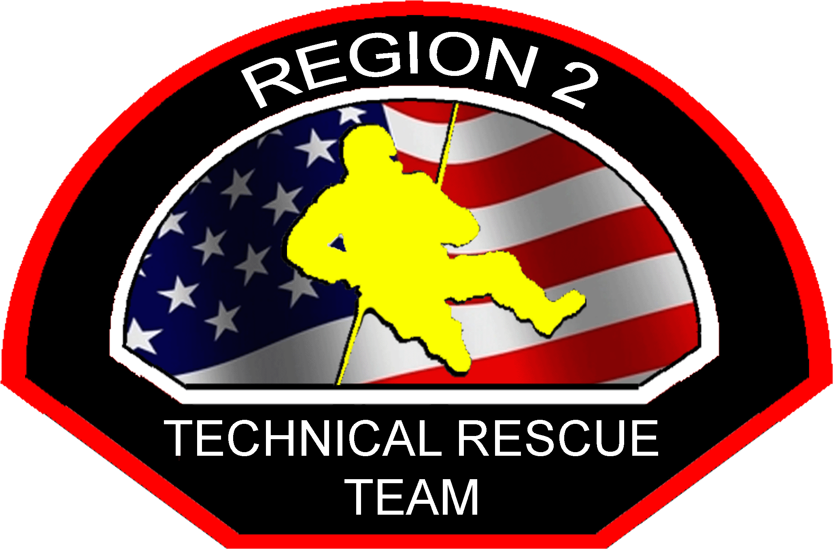
Region 2 Technical Rescue
Incident Reporting and After Action Review Policy

SCOPE: All R2TRT Members included in Kitsap, Clallam, and Jefferson Counties.

PURPOSE: To establish a R2TRT process for reporting a technical rescue response, and creating an After Action Review in one concise report.

GUIDE:
Technical Rescue work is complex, demanding and expensive. To succeed, the TRT must train our members to successfully execute their missions. We must use every training opportunity to improve the leadership, and unit task performance. To improve individual and collective-task performances, the TRT must know and understand what happened or did not happen during every real event or training.

Reporting all TRT incident responses and After Action Reviews (AARs) helps provide feedback on mission and task performances. Incident reporting tracks useful data for analysis regarding annual reports, types of calls, costs, frequency, equipment use, etc. After Action Reviews identify how to correct deficiencies, sustain strengths, and focus on performance of specific mission essential tasks. The environment and climate surrounding an AAR must be one in which the TRT members openly and honestly discuss what actually transpired in sufficient detail and clarity.

Multi-agency TRT reporting can be complicated and incidents can get missed. Therefore incident reporting and AARs must be funneled to the Lead Agency for accurate record keeping.

PROCESS:
- When any R2TRT response is dispatched, the responding TRT member shall forward an email report to the R2TRT Manager (R2TRT Lead Agency) and Department Agency Lead.
- The single report is both an incident report and AAR. It must include the following:
  - Who was involved, what happened, when, where, and how it was resolved
  - The incident number, and photos or video if available
  - Include what went good and what was bad. Opportunities for improvement.
- If an incident is not dispatched as a TRT response, but evolves into technical rescue work and units on scene perform TRT work a report shall also be filled out.
- No information regarding patient HIPPA protected information shall be included in the report. The report shall only remain focused on the team’s actions.
- AARs may be created following TRT training events if requested.

